Iconography is the branch of art history which studies the identification, description and the interpretation of the contents of images.

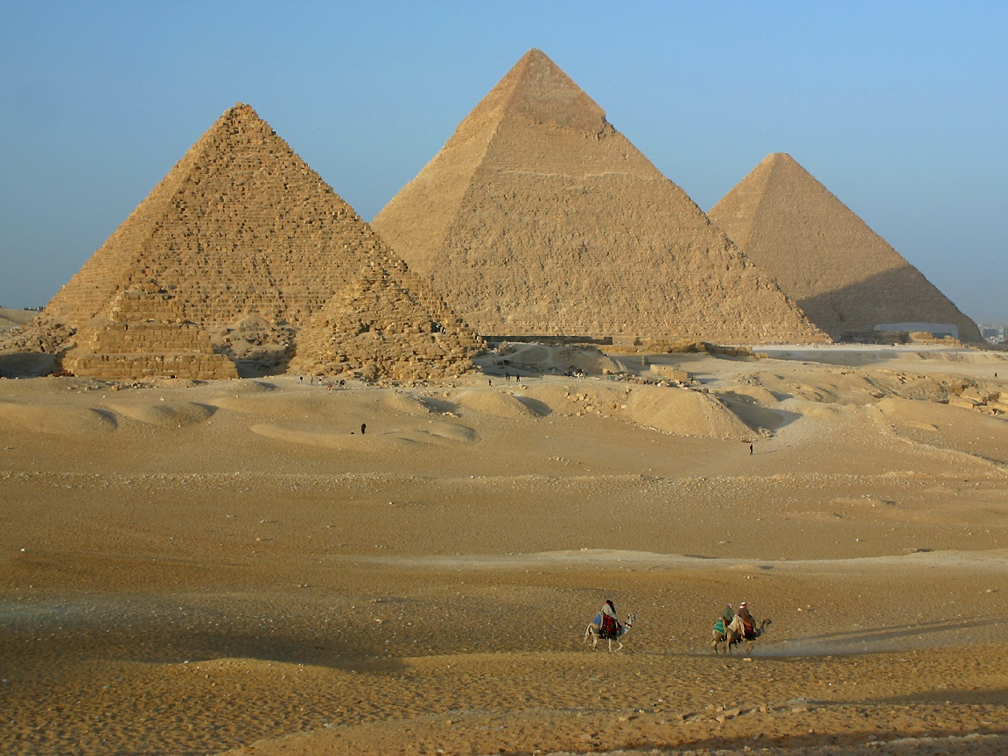  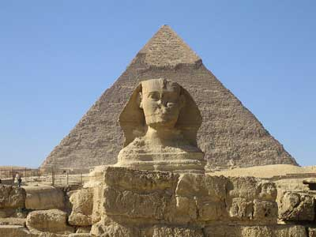 | The Great Pyramid  Giza; Egypt  The Great Pyramid of Giza located in Egypt is the oldest and largest at the site. The Great Pyramid of Khufu covers 13 acres at its base and is approximately 137 meters (450 feet) in height. It was originally cased with polished limestone, creating a smooth exterior. Over the years, the smooth limestone was looted and used in other parts of the world. The pyramids were built with huge red granite blocks that weighed about 2 ½ tons.  The Great Sphinx. To the Ancient Egyptians, the sphinx was a lion, which was a guardian to the sacred monuments. The lion had the head of a pharaoh who wore the royal headdress. Today his nose is missing.
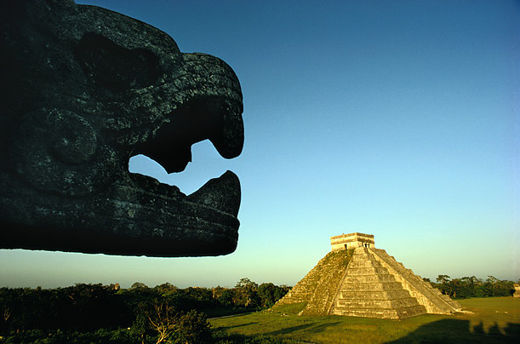  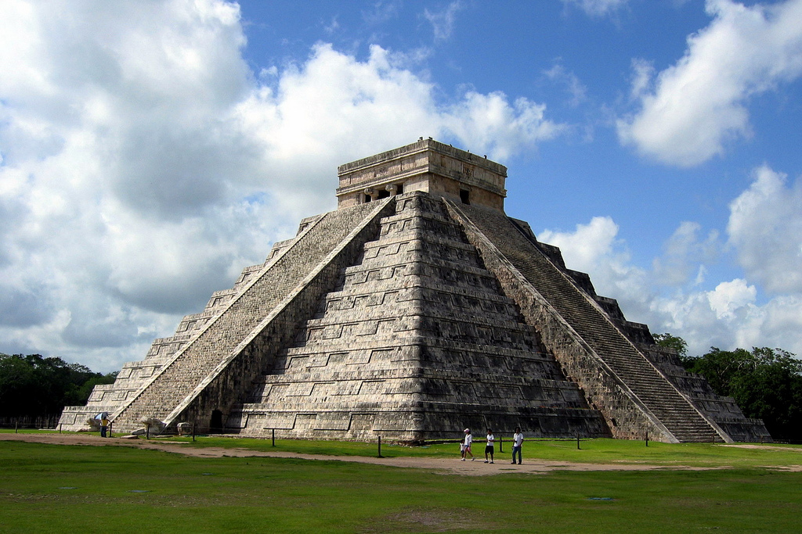 | Chichen Itza  Chichen Itza; Mexico  Chichen Itza is located in Mexico in the Yucatan Peninsula. It is the location of Mayan ruins. The best known construction on the site is Kukulcan's Pyramid, El Castillo, a square-based, stepped pyramid approximately 75 feet high. This pyramid was built for astronomical purposes and during the vernal equinox (March 20) and the autumnal equinox (September 21) at about 3 P.M. the sunlight bathes the western balustrade of the pyramid's main stairway. This causes seven isosceles triangles to form imitating the body of a serpent 37 yards long that creeps downwards until it joins the huge serpent's head carved in stone at the bottom of the stairway.
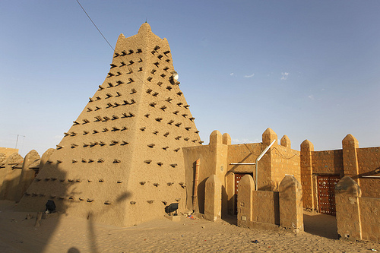 | Sankore Madrasah  Timbuktu; Mali  Sankore Mosque is the most recognizable image of the city Timbuktu. The city was transformed into a religious and intellectual center of the Islamic and Sub-Saharan African world during the Mali Empire. This is the Sankora Mosque (one of three) that made up the university.
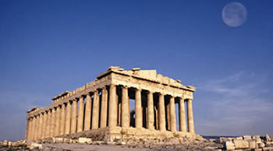  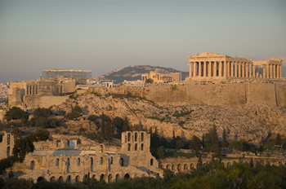 | Parthenon  Athens; Greece  The Parthenon is a temple to the goddess Athena and was built during the Age of Pericles. This building is considered a symbol of Ancient Greece and Athenian Democracy.
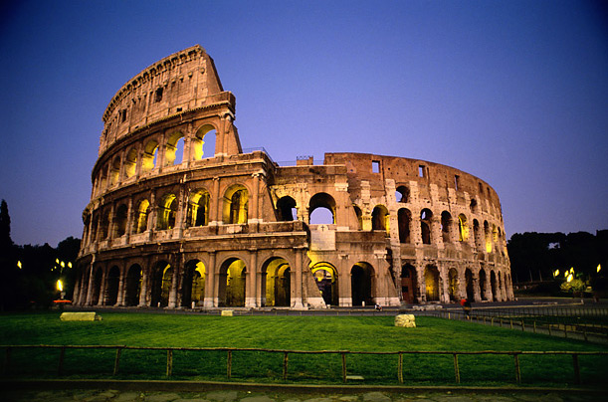 | Colosseum  Rome; Italy  The Colosseum is located in Rome, Italy. It is an amphitheater used during the Roman Empire for gladiatorial games and public spectacles.
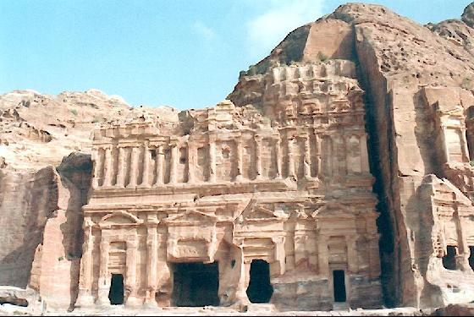  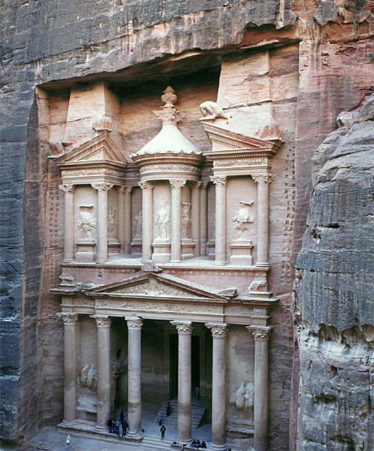 | Petra  Petra; Jordan  Petra is the historic and archaeological remains of a city located in Jordan built in the 6th century BC. It has become an image of Jordan as well as the most visited location in Jordan. It was chosen to be one of the new 7 Wonders of the World. Petra, located on the edge of the Arabian desert, was home to Aretas IV, king of the Nabataeans, who were masters of water technology. The facade of a 138 ft.—high Hellenistic temple on the El-Deir Monastery—an example of traditional Middle Eastern culture—sits within the Palace Tombs of Petra.
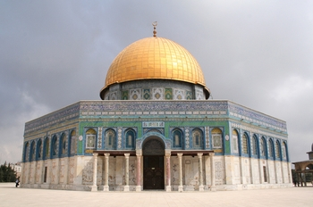 | Dome of the Rock  Jerusalem; Israel  This is the oldest example of Islamic architecture in the world. The Dome is located in Old Jerusalem. Construction of the Dome began during the Umayyad Dynasty. It was built on top of Mount Moriah (Mount Temple) connecting the Dome to Jewish and Christian traditions.
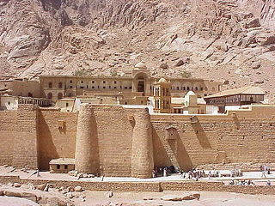 | Saint Catherine's Monastery  Sinai Peninsula; Egypt  There are claims that this is the oldest working Christian monastery in the world. Is the location of the oldest known image of Christ. (Another monastery across the Red Sea in the desert south of Cairo claims the same thing. :-)...)
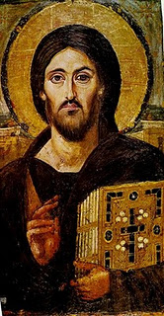 | Christ Pantocrator - Saint Catherine's Monastery  The oldest known image of Christ Pantocrator meaning "almighty." It is located in Saint Catherine's Monastery on the Sinai Peninsula in Egypt. The two different facial expressions on either side emphasize Christ's dual nature as fully God and fully human.
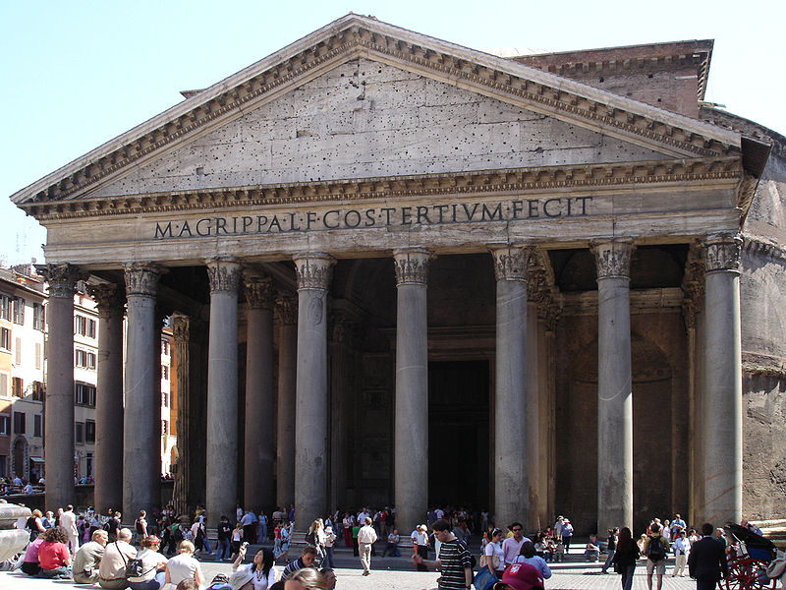  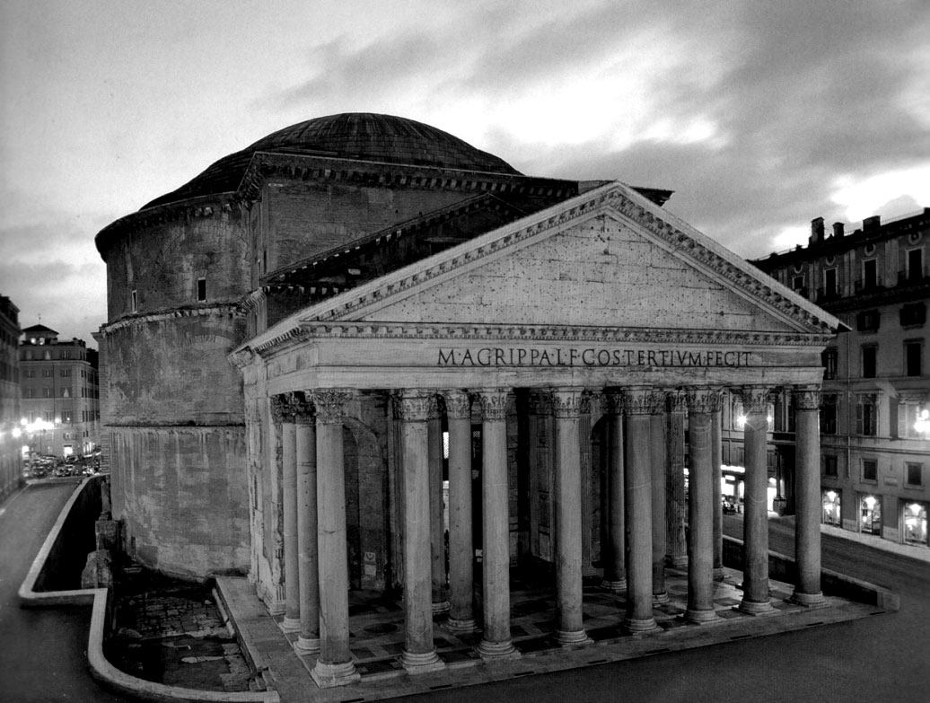 | Pantheon  Rome; Italy  The Pantheon was built for all the gods of Ancient Rome. Almost two thousand years after it was built, the Pantheon's dome is the world's largest unreinforced concrete dome. It is still used today for worship.
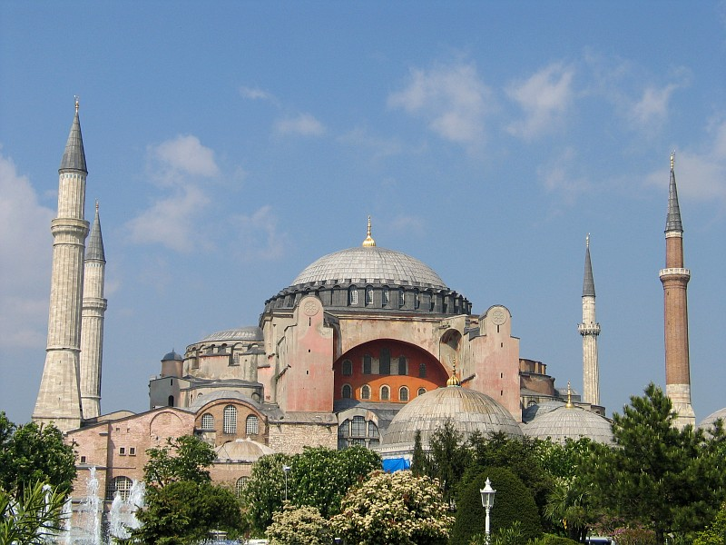 | Hagia Sophia  Istanbul; Turkey  This was the seat of the Patriarch of Constantinople and religious focal point of the Eastern Orthodox Church for nearly 1,000 years. It was built on the orders of Emperor Justinian and is the epitome of Byzantine architecture. It was later on a mosque during the Ottoman Empire and has been converted into a museum. The city's name has also been changed to Istanbul.
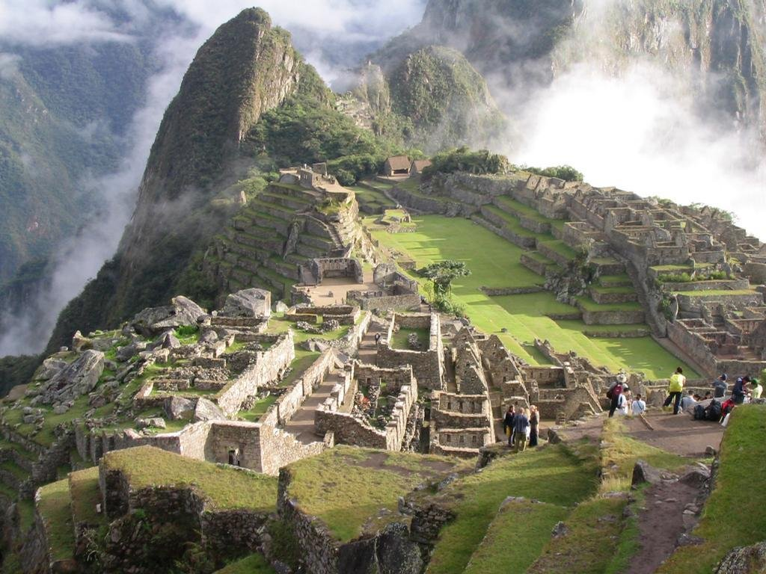 | Machu Picchu  Machu Picchu; Peru  Machu Picchu, which means "old settlement," is located halfway up the Andes Plateau—in the Amazon jungle and above the Urubamba River. Originally a 15th century Incan settlement, the magnificent city was "lost" for three centuries, then rediscovered in 1911.
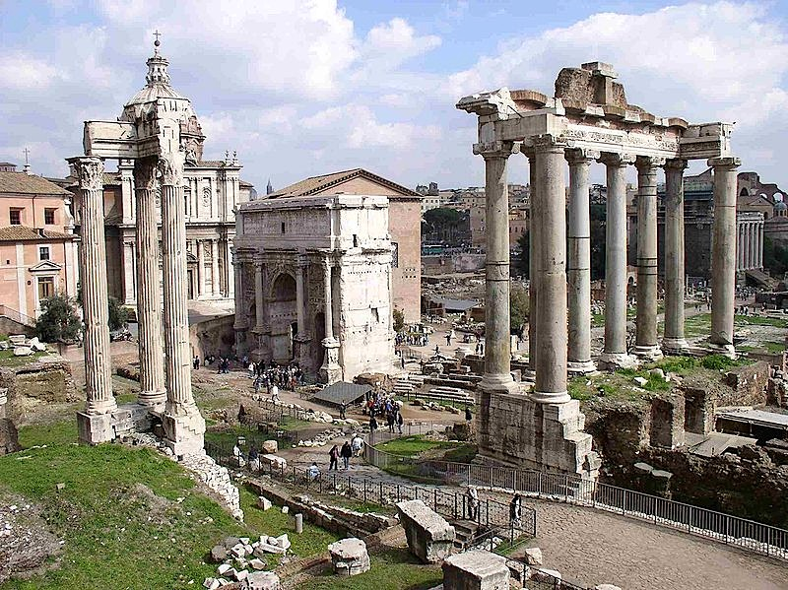 | Roman Forum  Rome; Italy  The oldest and most important structures of Ancient Rome are located in the Roman Forum built on the Palatine Hill. The Old Republic had its formal Comitium there where the Senate, and the Republican government began. The Forum served as the city center where Roman citizens gathered for justice and faith.
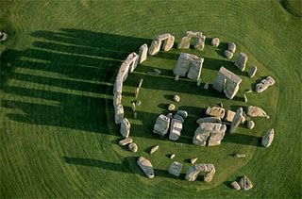  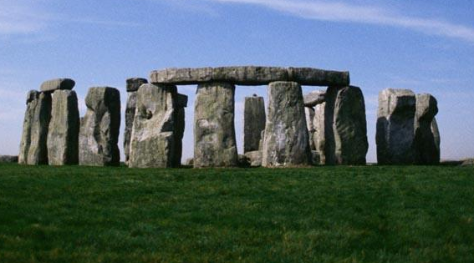 | Stonehenge  Wiltshire; United Kingdom  Its original purpose is unclear to us, but some have speculated that it was a) a temple made for the worship of ancient earth deities b) an astronomical observatory for marking significant events on the prehistoric calendar c) a sacred site for the burial of high-ranking citizens from the societies of long ago. Construction of the monument has been attributed to many ancient peoples throughout the years: Druids, people of the neolithic period, and Beaker Folk (named thus for their pottery work). The inner circle (bluestones weighing 4 tons) was built about 2,000 BC and the outer circle (giant sarsen stones weighing up to 50 tons) added later on, possibly by another people.

